Quantitative Finance Qualifying Exam

2017 Summer

INSTRUCTIONS
You have 4 hours to do this exam.

Reminder: This exam is closed notes and closed books. No electronic devices are permitted.
Phones must be turned completely off for the duration of the exam.

PART 1: Do 2 out of problems 1, 2, 3.
PART 2: Do 2 out of problems 4, 5, 6.
PART 3: Do 2 out of problems 7, 8, 9.
PART 4: Do 2 out of problems 10, 11, 12.

All problems are weighted equally.
On this cover page write which eight problems you want graded.

Problems to be graded:

Academic integrity is expected of all students at all times, whether in the presence or absence of members of the faculty.
Understanding this, I declare that I shall not give, use, or receive unauthorized aid in this examination.
Name (PRINT CLEARLY), ID number:

Signature

Stony Brook University

Applied Mathematics and Statistics

Spot Rate Computation and Applications

You are given the following information. Assume annual compounding throughout.
- A 1-year zero-coupon bond with a face value of $100,000 sells at a discount of $98,522.17.
- A 2-year bond with a face value of $10,000 and an annual coupon of $300 sells at price of $10,099.25.
- A 3-year bond with a face value of $100,000 and an annual coupon of $3,100 sells at a price of $100,356.00.
Solve for the following:
- Spot Curve: Using the market data, above compute the 3-year spot curve.
- Bond Valuation: Using the spot rates computed above compute the price of a 3-year bond with a face value of $1,000,000 and annual coupon of $2,000.
- Forward Rate: Compute the forward rate f_{2,3}.

Market Portfolio

Consider the following simple quadratic program representing the portfolios on the Capital Market Line (CML) and its solution to proportionality. The parameters μ and Σ, are the returns' mean vector and covariance matrix, respectively, and r_{f} is the risk-free rate. The value of λ ≥ 0 parameterizes the CML:
Assume the Capital Asset Pricing Model (CAPM), i.e., at time t for an asset i with return r_{i}(t), market M with return r_{M}(t) and risk-free rate r_{f}, and mean-zero, uncorrelated error terms ε_{i}(t), the following expression holds
Further assume that the covariance matrix is invertible. Show that the value of x_{i}, the allocation of asset i in the market portfolio, is proportional to

Chooser European Option

A standard chooser European option is one in which the option holder has the right to decide if the option is a vanilla European put or a call at some point prior to the expiry of the option. We assume that the strike price K and expiry T are the same for both the put and call. The current time is t and the time the choice must be made is τ with 0 ≤ t ≤ τ ≤ T. Write the expression for the price of the chooser F(t) in terms of vanilla European options and, if necessary, any discounted cash-flows.

Power Law Model

We wish to investigate the lower tail of a return distribution. Let Q(x) = Prob[X ≥ x] denote the survival function of x. A log-log plot of the survival function for x ≥ 0 is shown below.
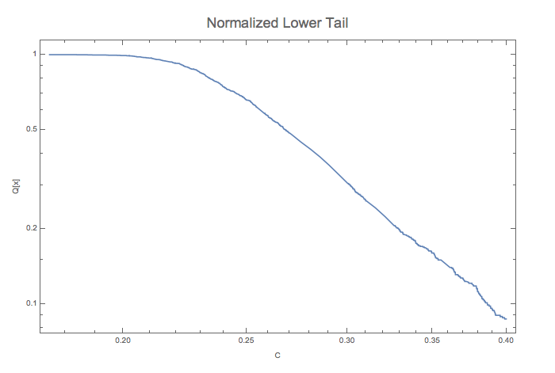
- Does the distribution of x display at any point evidence that the tail of the distribution follows a power law? Explain what you looked for to determine this.
- If so, at what point does that behavior emerge? Explain your answer.
- If there is evidence of a power law in the upper tail, estimate its exponent. Employ a simple visual approximation but explain how you accomplished it. If not, hypothesize a reasonable return distribution.
- Based on your work above, define to proportionality the PDF and CDF of the upper tail in the power law region.
- What can you say about the existence of the moments of the distribution based on the work above? Explain you answer.

Markowitz Portfolio

Assume that returns follow a multivariate Normal distribution with mean vector μ, positive-definite covariance matrix Σ and risk-free rate r_{f} . The mean-variance portfolio optimization with unit capital is the quadratic program below. Note that both long and short positions are allowed in this instance.
$$M=\min_{x}\left\{\frac{1}{2}x^{T}Σ x-λ {(μ^{T}-r_{f})}^{T}x | 1^{T}x=1\right\}$$
where the risk-reward trade-off is controlled by the parameter 0 ≤ λ.
- Assuming an investor population of mean-variance optimizers, derive an expression for the market (i.e., tangent) portfolio.
- Given that different investors have different return goals or risk preferences, explain how an investor uses cash and market portfolio to achieve them.
- Explain why the approach you described in (b) above is superior in mean-variance terms to any other strategy.

Copula

Assume all distributions’ CDFs in this question are continuous, monotonically increasing functions. Let F_{X}(x) be the CDF of a multivariate random variable X with marginals F_{Xi}(x_{i}), i ={ 1, … , n} and let Uniform[0, 1] designate the uniform distribution on the unit interval.
- Show that the random variable U = F_{Xi}(X_{i}) ~ Uniform[0, 1].
- Let H_{Z}(z) be the CDF of a continuous univariate random variable Z. Show that the random variable H_{Z} ^{–1}(U) where U ~ Uniform[0, 1] realizes a random variable with the same distribution as Z.
- Derive the copula associated with F_{X}(x), i.e., a function C_{X}(u), u = {u₁, … ,u_{n}} where C is a multivariate CDF with Uniform[0, 1] marginals, representing the dependence structure of F_{X}(x) separate from its marginals.
- Let G_{Yi}[y_{i}], i ={ 1, … , n} designate the CDFs of continuous univariate random variables Y_{i}. We wish to construct a multivariate distribution G_{Y}[y] with marginals G_{Yi}[y_{i}] and the same dependence structure as F_{X}(x). Write an expression for G_{Y}[y] which accomplishes this.

VaR of a European Call

Consider a European call option with parameters as follows: current stock price S₀, strike K, risk-free rate r, volatility rate σ, and time to maturity T years.
Assuming a geometric Brownian motion for the stock price process S_{t}, use the delta-normal valuation to compute the 95% VaR over a horizon of 3 days for a long position of a European call.

Kendall Tau

Let X = (X₁, X₂) be a bivariate Gaussian copula with correlation 0.5 and continuous margins.
Show that the Kendall's τ is:
ρ_{τ}(X₁, X₂) = ⅓

VaR of a GARCH Process

Consider the following AR(1)-GARCH(1,1) model for daily return r_{t} :
$r_{t}=θr_{t-1}+u_{t}$ $u_{t}=σ_{t}ε_{t}$ $σ_{t}^{2}=ω+αu_{t-1}^{2}+βσ_{t-1}^{2}$
where –1 < θ < 1; θ ≠ 0; α > 0; β > 0; ω > 0 and α + β < 1.
What is the 99% 2-day VaR of a long position at time t ?

Heat Equation

Compute the partial derivatives of the normal Gaussian distribution function g with respect to space and time: $\frac{∂g}{∂x}$ , $\frac{∂^{2}g}{∂x^{2}}$ and $\frac{∂g}{∂t}$ , where:
$$g\left(x,t\right)=\frac{1}{\sqrt{2πt}}\text{exp}\left(-\frac{x^{2}}{2t}\right)$$
Verify Kolmogorov PDE (a.k.a. heat equation):
$$\frac{∂^{2}g}{∂x^{2}}(x,t)=\frac{∂g}{∂t}(x,t)$$

Shifted Log-Normal Process

Consider a shifted log-normal model for an option on a stock S_{t}. A shifted log-normal process is given by:
$$dS_{t}=\left(S_{t}+δ\right)α_{δ}dt+\left(S_{t}+δ\right)β_{δ}dW$$
- Show that, at maturity T, the distribution of D_{T} = S_{T} + δ is log-normal and give its formula, then the formula for the distribution function of S_{T} .
Reminder: if f(x) is the pdf of a random variable X, then the pdf of Y = exp(X) is yf(Ln(y))
Don’t forget the Itô term when computing the distribution of Ln(D_{T})
- Compute the expectation μ = E(S_{T}) and the variance σ = Var(S_{T}) with respect to S₀, δ, α_{δ} and β_{δ}
- Given S₀, δ, μ and σ, compute α_{δ} and β_{δ}
- Show that, when d → +∞, with fixed μ and σ, then the distribution of S_{T} tends to a Gaussian distribution

Random Variables of Class L^{p}

We recall that a random variable X on a probability space (Ω, ℑ, P) is of class L^{p} if E(|X|^{p}) < +∞.
Show that if X is of class L², it is of class L¹.
(hint: Cauchy-Schwarz inequality)
More generally, show that if 0 < q < p then if X is of class L^{p}, it is of class L^{q}.
(hint: consider the events A = {|X| ≤ 1} and B = {|X| > 1})

Scratch paper 1

Scratch paper 2

Scratch paper 3

Scratch paper 4

Scratch paper 5

Scratch paper 6

Scratch paper 7

Scratch paper 8

Scratch paper 9

Scratch paper 10

Scratch paper 11

Scratch paper 12

Scratch paper 13

Scratch paper 14

Scratch paper 15

