AP Invoice
User Guide

AP Invoice User Guide – Processing Invoices
Last Updated: 11/30/2021

Important Note

As the Avid system is managing sensitive financial information – there is security build in to protect these transactions. When an SBF user is logged on, if there are 10 minutes of inactivity, the system will automatically “time out” and log the user off the system. Please utilize the “Update” and “Update Detail Line” buttons to save your work.

Introduction: This document is an Avid site guide designed for SBF users. Here are the topics covered:
- Processing an Invoice Manually
  - Logging on / Home Screen / Status of your AP invoices.………………………… 1-4
  - Starting a new invoice transaction…………………………………………………………. 4-5
  - Creating an AP invoice header screen…………………………………………………….. 5-7
  - Uploading a document…………………………………………………………………………… 7-8
  - Adding invoice details…………………………………………………………………………….. 9-11
  - GL Coding – (Distribution Lines) ……………….……………………………………………. 11-13
  - Submitting your completed invoice………………………………………………………. 14
- SBF Issued Purchase Orders…………………………………………………………………………………. 14
- Key buttons and their functionality…………………………………………………………………… 15-19
  - Cloning an Invoice…………………………………………………………………………………. 16-19
- Support Contacts………………………………………………………………………………………………. 19
- Sorting, Filtering and View Options…………………………………………………………………… 20-22

Processing an Invoice:

Log in to the SBF Avid site. https://sbf.arietttouch.net/

STEP ONE - type in your User Name and Password. Your user name will match how your name is spelled for your SBU e-mail. KEY NOTE: Make sure to include the period between your first and last name. On your first login, all users will have the same password which is Password123 (the “P” is in caps). Click on “Sign In” to go to the Home Screen

KEY NOTE: Please make sure to read the language on the top of the websites log-in page in the blue highlighted box. This is your attestation that this transaction meets the donor’s intentions and complies with the Foundation’s policies and procedures

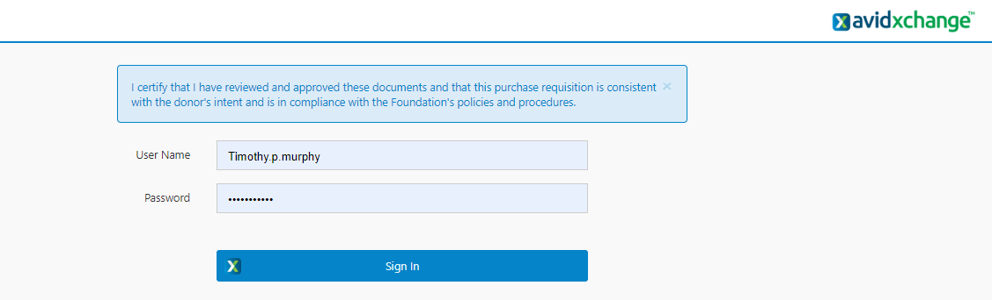

Once you have accessed the Avid system for the first time, you need to create your own unique password. Please follow the steps below:
- Click on the hamburger sidebar menu in the top left corner
- Click on “User Options”
- In the User Password section, type in the New Password in both fields
- Click Update
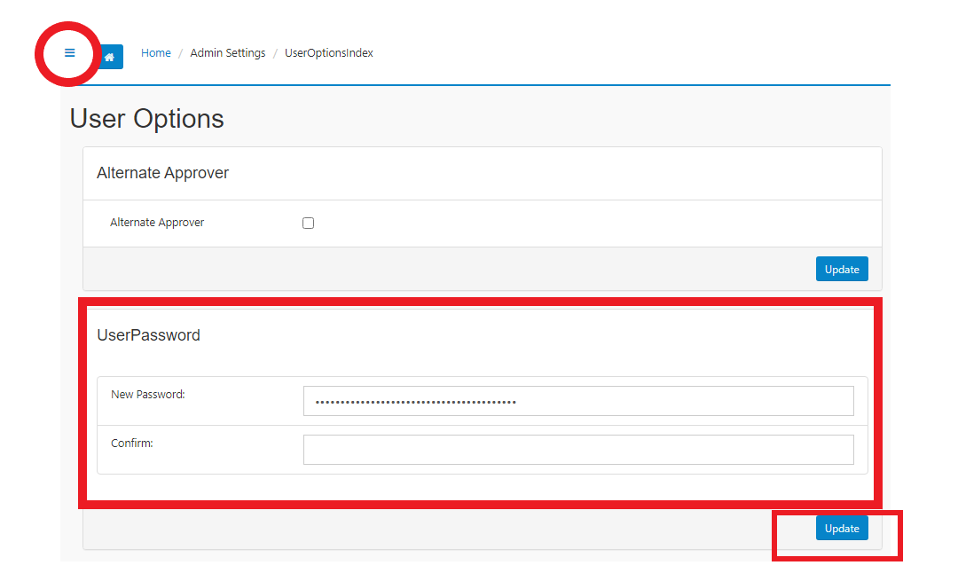

Password Requirements:
- At least 7 characters
- At least one capital letter
- At least one lowercase letter
- At least one number or special character
- Special characters allowed: !, #, $
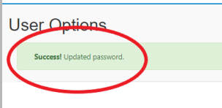

You have now successfully created your own unique password. Click on the “Home” button on the top of the page to return to the Home Screen
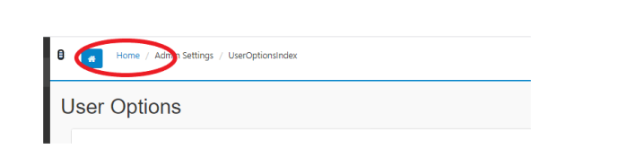

Home Screen – This gives you a status of your AP invoices

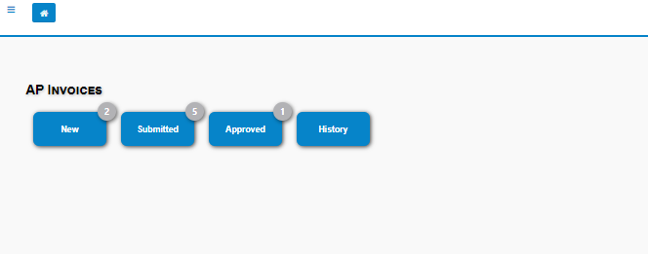
- NOTE: The number in the upper-right corner is a count of your existing Invoices.

New
- Transactions that have been started but not submitted
- Any rejected transactions that need your attention
Submitted:
- Transactions that have been submitted by you
- Transactions that have been submitted to you for approval
Approved:
- Your transactions which have been fully approved
History:
- See page # 22

STEP TWO – To open the screen for a new invoice transaction - click on “New”

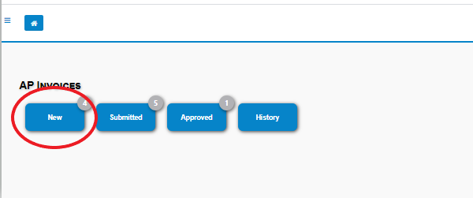

STEP THREE - Click New in the upper-left corner to start a new invoice transaction. The AP Invoice Header will be opened for edit.
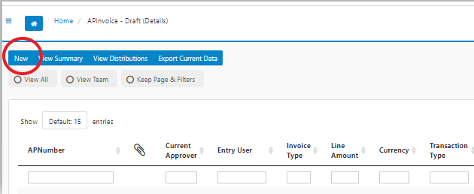

STEP FOUR – This is the AP Invoice Header Screen. Fill in the fields as applicable.
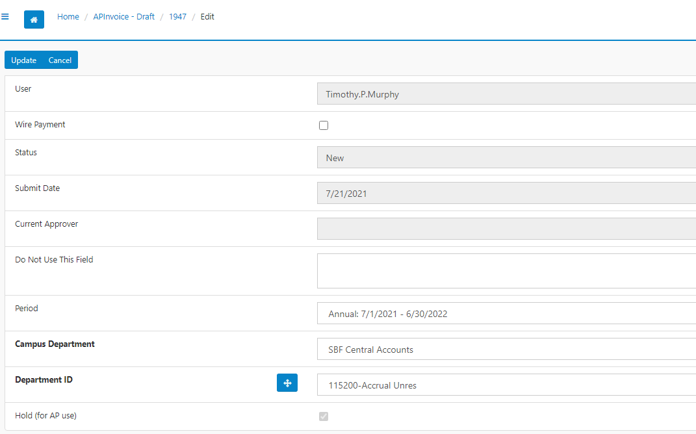

KEY NOTES
- If you do not populate a required field you will receive an error message in red at the top of the screen when you try to move to the next step
- User will auto populate based on the logged in SBF user creating the transaction
- Wire Payments - When the payment needs to be paid by wire, make sure to check the “Wire Payment” Button. The department must add a comment in the “Add Comment” section and scan the Bank Verification letter along with invoice. The SBF charges wire fees: Domestic $15.00 / Foreign $30.00. These comments can be added only AFTER you hit Update -See STEP FIVE
- Status and Submit Date will automatically populate. Status and Current Approver will update as the transaction moves through the approval workflow
- Period - SBF will have the period defaulted to the current school year

In the drop down, menu – first select your Campus Department and then select your Department # (Note this is your SBF Account #) NOTE –In both drop down menus, if your start to type in numbers or words, it will narrow your search.

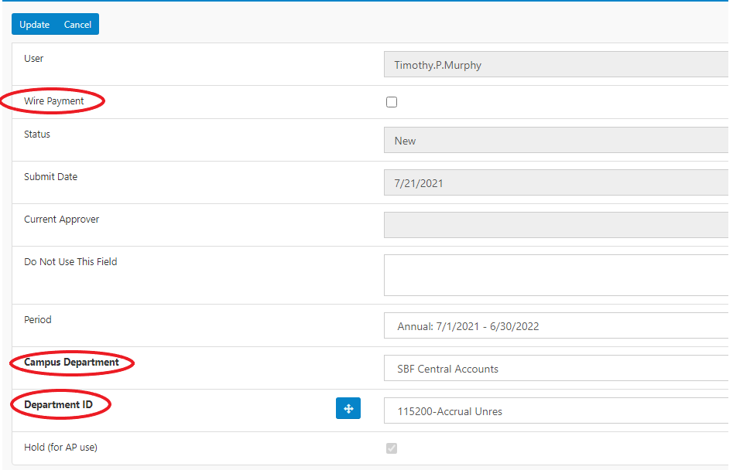

STEP FIVE Click Update once all the necessary fields have been completed. You have now completed the AP Invoice Header section. After you hit Update – the “Add Comment” field will appear. Please use this section to share any special instructions to the SBF AP Team

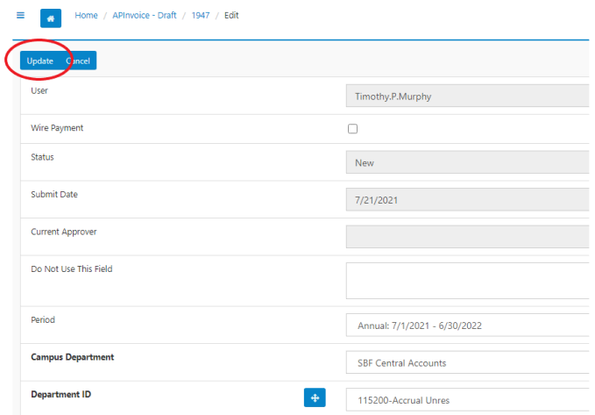

STEP SIX Click Add New Row to begin adding the invoice detail lines.

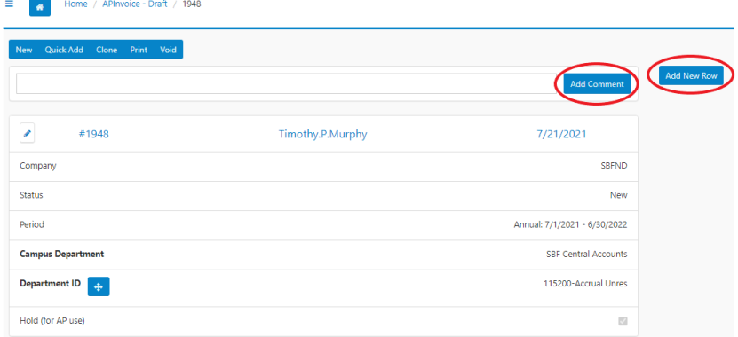

KEY NOTE: The “Add Comment” field is very good place to communicate key information with the SBF AP Staff. Please always start a comment with the date i.e. 7.15.21

STEP SEVEN Uploading a Document

Click Upload in the upper-right hand corner of the detail line edit screen.
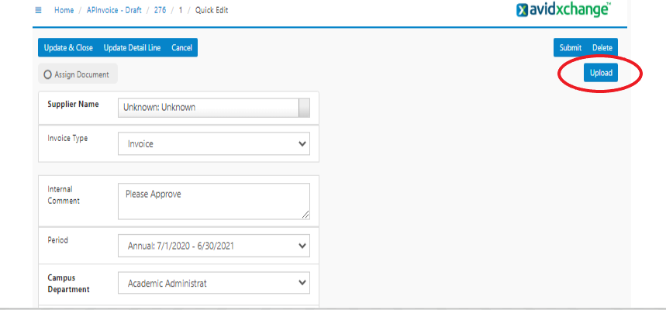
The system will ask if you want to upload – click OK as no values had been previously loaded
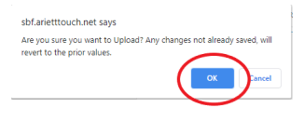

Click Choose File in the pop-up window. NOTE If this invoice is associated with an SBF Purchase Order, you must also scan in a copy of the PO in addition to the invoice. NOTE -2 there is a 20 mb limit on the file size

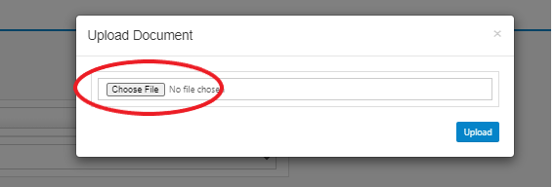

Navigate to the file you want to upload and click Open. The file uploaded must be a PDF
Click Upload.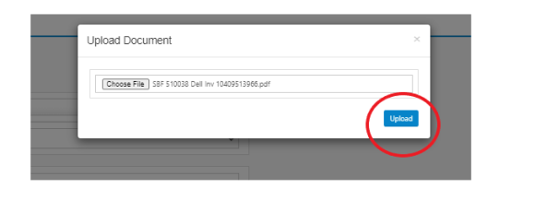

STEP EIGHT Adding Invoice Details:
Once a file is uploaded it will display on the right side of the detail line edit screen. Fill out all applicable detail fields on the left side of the screen.
- Select the Supplier from the Supplier Name drop down list. Typing “ALL” will populate the full list. Typing 3+ characters from the vendor ID or vendor name will narrow the list.
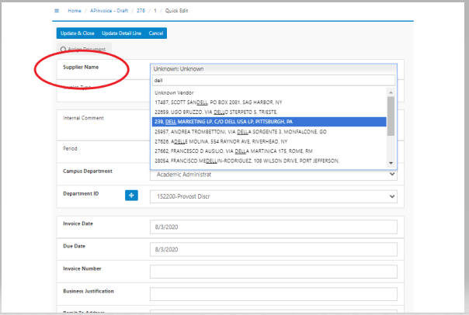

Important Note - If your supplier doesn’t appear in the drop-down menu, you cannot proceed with this transaction. So that SBF AP can load your vendor into Avid, please complete an SBF Vendor Set-up Form; this can be found on the SBF website in the “Spending Money from Your Account” section under Forms.

The next section displays fields from the previously created header. Changes here will save to the header. Enter an Internal Comment starting with the date (i.e. 10.13.20) if applicable.

Continue filling out the next section of fields; any section that is bolded on this screen is a required field:
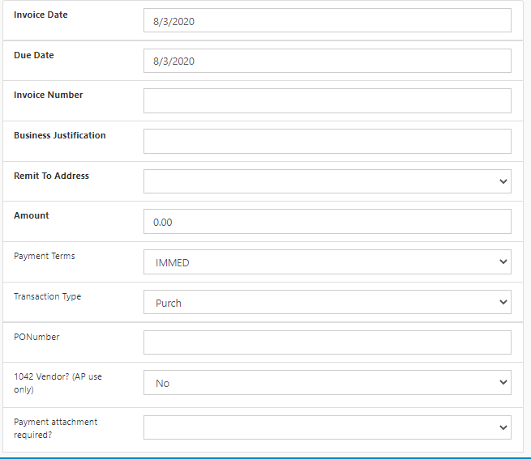
- Invoice Date
- Due Date
- Invoice Number (Always required)
- Business Justification (detail how this
transaction meets donor intentions)
- Remit to Address (Will auto populate but
User can also select second address)
- Amount
- Payment Terms (Will default to IMMED)
- Transaction Type (System will default
to “Purch” unless the user is entering a
a Credit Memo)
- Payment attachment required?
(This field will advise the AP staff to
send the check along with the return
payment coupon)

STEP NINE- Click Update Detail Line to save all changes.

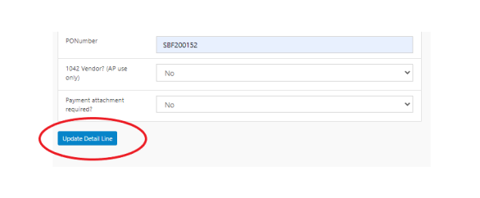

STEP TEN - Scroll to the bottom of the screen to view and edit the GL Accounts (Distribution Lines) Note – If you need to split charges between departments – you can make multiple entries by the different department’s IDs in this section.

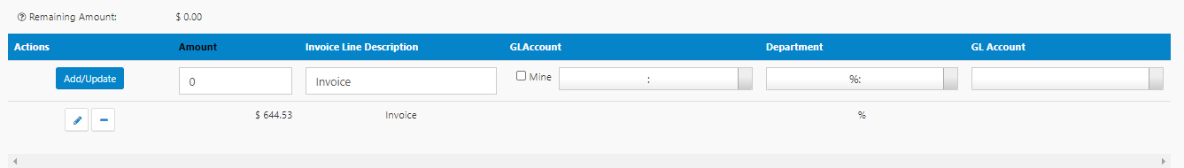

Key steps for this section:
- Click on the small pencil – that is the edit button
NOTE: the rest of this section must be completed from the right to the left
- “GL Account”- this is the general ledger accounting code to define the type of expense.
When clicking on the field the system will show a list of GL codes to choose from. Refer
to the SBF GL Account Codes Guide for definitions
- “Department” – it should match the department selected on the Invoice Header
- “GL Account” – this is the combination of the Department ID and the GL account selected. NOTE: if this field is blank - please go back to step #2 and select a different GL Account
- Invoice Line Description – Populate this field with what you want to see on your monthly accounting reports – NOTE there is a 30 character limit
- Amount – this field with be populated with the invoice dollar amount
5

4
3
2
6
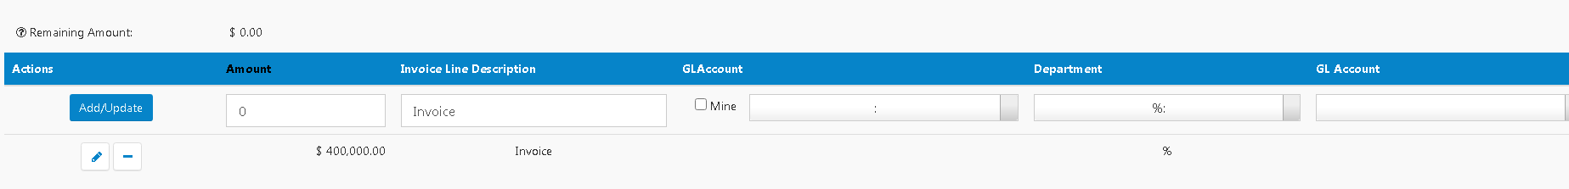
1

STEP ELEVEN – Once you have completed actions 1 thru 6 – click on the ADD/UPDATE Button

If the GL Coding is properly completed the screen will show $0.00 in the “remaining amount” and Amount, GL Account and Department will appear on the bottom of the screen
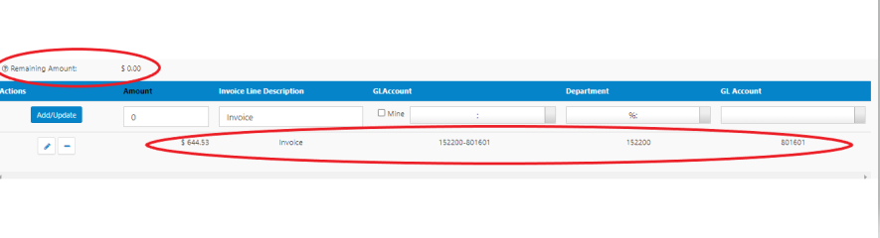

STEP TWELVE - At the top of the screen Click Update & Close to return to the Transaction Overview Screen or click Submit to send the transaction down the approval route.

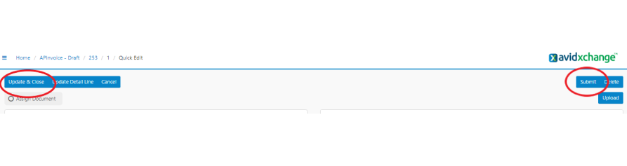

The Submit button is also available from the Transaction Overview Screen.
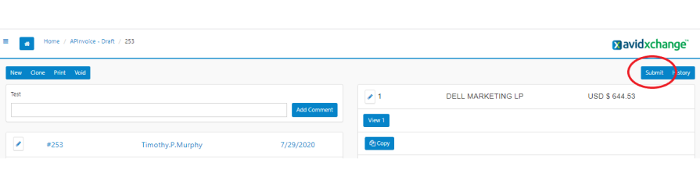

Once you have successfully submitted an invoice, you will receive the following mesaage
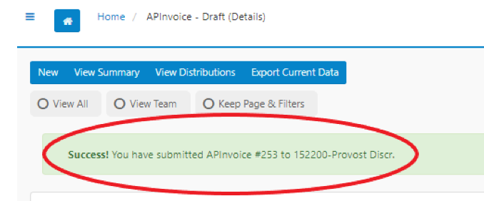

SBF issued Purchase Order – Key Call Outs

- New Purchase Order - If you want to create a new SBF PO – please complete the requisition form for the SBF website along with the vendor quote and e-mail it to the SBF Procurement team SBF_PO@stonybrookfoundation.org
- Existing SBF Purchase Orders – the SBF staff will load the vendor invoices into the Avid system for you. You will receive an e-mail alert from Avid with a link to the system seeking your approval. Both the recent vendor invoice as well as the Purchase Order will included as attachments. Please review and provide your approval and/or send back for further clarification.
- Vendor Invoices related to a SBF PO – If a vendor should send you an invoice directly – please DO NOT enter it into Avid. E-mail the invoice to the SBF AP team and they will enter it for you into Avid for approval. SBF_AP@stonybrookfoundation.org

Key Buttons and their Functionality

Update & Close - saves your most recent updates and returns the user to the APInvoice Transaction Overview Screen
Update Detail Line - you will be able to update the AP invoice details and/or the GL Account coding
Cancel - also brings you to the APInvoice Transaction Overview Screen.
Delete – DO NOT use this as the functionality is not currently supported. If you want to delete a transaction, please reach out to the SBF AP team. SBF_AP@stonybrookfoundation.org

The system will transfer the APInvoice to the History queue. The voided transaction cannot be re-used.
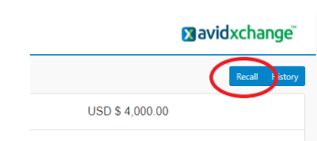
If you want to recall a submitted transaction – you can utilize the “Recall” button that is in the upper right-hand corner. This will move the transaction back into your New que. Note – you cannot use the Recall function if you manager has already approved the invoice.

KEY NOTE - The SBF preference is to have one header with one invoice to avoid confusion. As such, the “Copy” button is NOT a supported SBF function at this time – please do not use

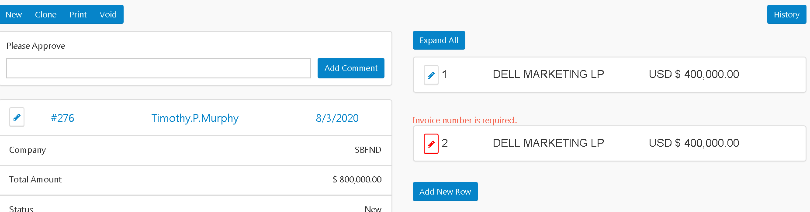

is useful when the user has a recurring AP invoice. Avid will copy and create a new transaction with most of the information from the original AP invoice.

STEP ONE – Go in to the home screen and double click on the voucher # to open a previously submitted invoice transaction

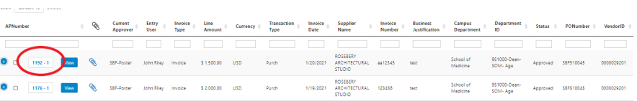

STEP TWO Once you have opened the transaction click the “Clone” bottom on the top left side of the screen

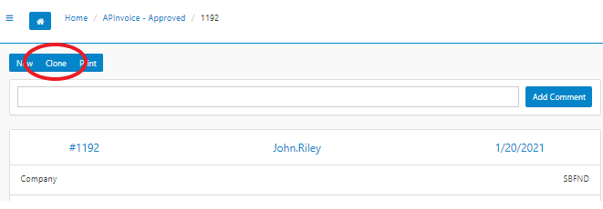

STEP THREE – The system will ask if you want to clone this transaction – click “OK”

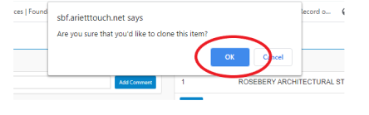

STEP FOUR – The system has now cloned many of the previous transaction’s data points into a new invoice transaction. The system will prompt you to add a new document with a new invoice number – click on the red pencil to start a new upload.

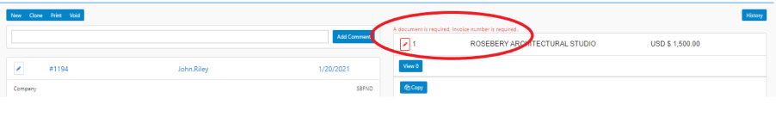
STEP FIVE – Follow the upload steps as called out on pages 5 and 6 in this manual

STEP SIX – One you have uploaded the new document, you will need to fill some fields like: Invoice Number, Amount, and PONumber

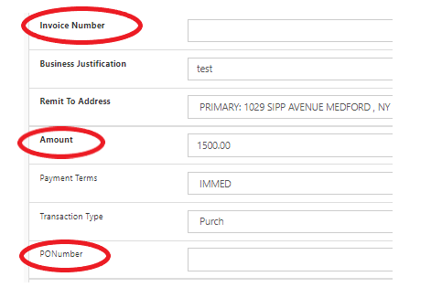

STEP SEVEN - Click Update Detail Line to save all changes.

STEP EIGHT – Follow the “GL Accounts (Distribution Lines)” from pages 11 thru 13 in this manual.
Important Note – The GL Coding from the initial transaction will be copied into the cloned transaction. You may need to modify/adjust the previous GL Accounts coding from the cloned transaction to properly reflect the new transaction – i.e. dollar amounts, number of GL lines…etc.

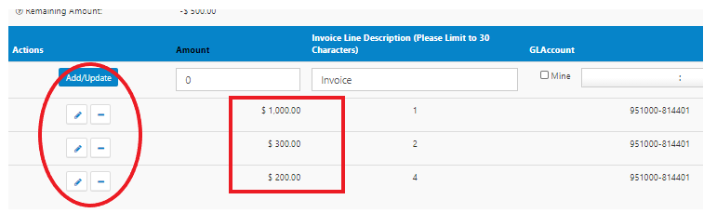

STEP NINE – Follow the “Submit” steps as called out on pages 13 and 14 of this manual.

Supporting Your Needs
Avid System Support Contacts
- SBF Business Office – (631)-632-6536
- Veronica Tator-Cevallos – cevallos@stonybrookfoundation.org
- Peggy Riggs – peggy.riggs@stonybrookfoundation.org
- Linda Wu – Kueilin.wu@stonybrookfoundation.org
Adding New Users/ New Vendors
- SBF_AVID_User@stonybrookfoundation.org
Training Support
- Tim Murphy – timothy.murphy@stonybrookfoundation.og

Sorting, Filtering, and View Options:

Regardless if you click on the New, Submitted, Approved, or Finalized buttons from your home screen, there will be various “View” options available in the upper left corner of the screen.
- NOTE: The available options may vary based on your system access.
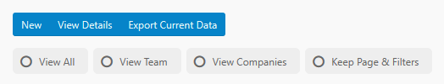

View Details: brings you from summary view into detail view, where detail line items for each transaction will each be individually displayed.
View Summary: brings you from detail view to summary view, where each transaction will be displayed with header information.
View All: View all active product transactions.
View Team: View all active product transactions where you have a workflow presence.
View Companies: View all active product transactions across all companies.
- NOTE: View Companies includes View All or View Teams selection as well.
Keep Page & Filters: Preserve any active filtering and sorting while browsing through transactions.

Most Avid queues also share a common layout and Sorting and Filtering functionality. Below is an example of what a standard queue looks like.
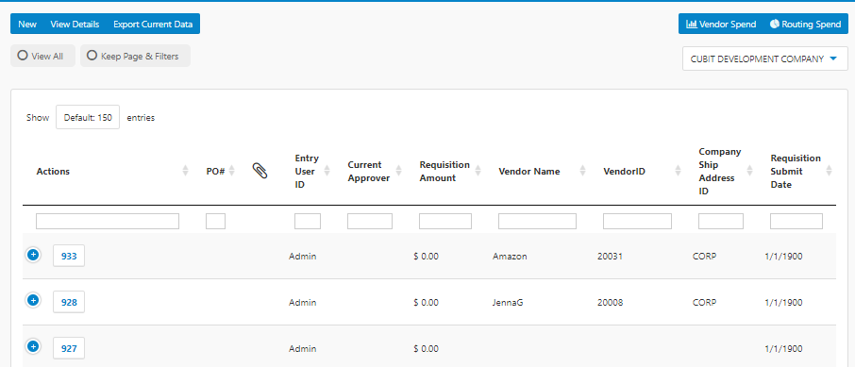

Clicking on a column heading will sort the table by that column.

- The first click will sort the table in Ascending alphabetical or numerical order.
- Each click after that will toggle between sorting in ascending and descending order.
- The arrows next to the column header will indicate which direction the table is sorting.

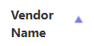

Underneath each searchable column heading is a text box. Typing into this field and hitting enter will filter the column to display entries that match the text, making it easier to find a specific transaction.
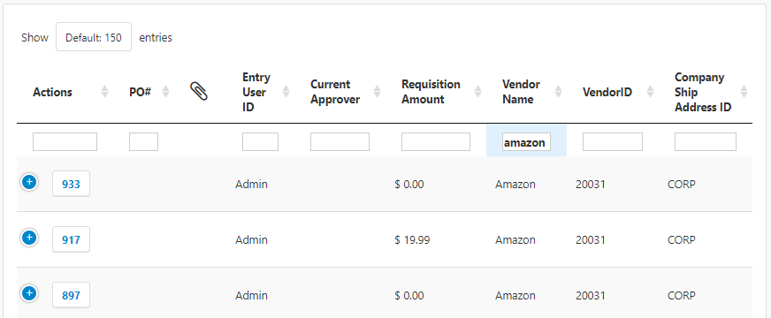

- To remove a filter, delete the existing text and hit enter. The screen will now display all available transactions.

History
- Status
  - Posted means the transaction has been posted to PeopleSoft
  - Void – means the transaction has been cancelled
- Voucher Number – a check is scheduled to be paid in PeopleSoft – Check runs are every Monday

