Spin Casting Polymer Thin Films

The main objectives of this lab are:
I. Learning good research protocols: keeping an accurate laboratory notebook, good laboratory "hygiene", which means: respect for equipment and people; avoid contamination; know which PPE to wear and when, and proper disposal of hazardous chemical waste. Additionally, learning good research; researching from literatures, citing the references, understanding the context of the published articles, then critically thinking in scientific reasons and extracting the information out of the data.
II. Learning to work in a group: modern science relies on interdisciplinary collaborations. This involves learning to work in teams where each member produces an ORIGINAL contribution that advances the mission of the project as a whole. Teamwork is harder than you realize. It requires coordination, respect for others, and knowledge of research other than your own.
The goals of this experiment are:
- Learn how to process silicon wafer surfaces and understand its crystal structures
- Spin-casting polymer thin films and measure the thin-film thickness
- Determine the molecular weight of unknown polystyrene from known molecular weight polystyrene
There are 8 activities in this experiment:
- Cleave silicon wafer, dust off with nitrogen gas and clean with chemicals
  - Graduate leaders will teach students how to cleave and clean silicon properly
  - Remember: Students will need to dispose the silicon and sharp edge in sharp- edge disposal bin
  - Students need to learn to collaborate and comply with graduate students at all time during experiments

- Using Optical Microscope to look at the silicon crystal
  - Graduate students will show students how to look at the crystals using optical microscope in room 205B Engineering Bldg.
  - Students need to observe the crystal structure of silicon: (1) [100] and (2) [111]
  - Miller’s index using optical microscope with 10x and 50x magnification
  - Students need to be able to observe the crystal structure of the silicon and be able to explain what the crystal structure of each Miller’s index looks like and why. What’s the type of silicon [111] or [100] that the crystal looks rectangular and what’s the type of crystal that looks more triangular (tetrahedral crystal structure).
  - Students must be able to use ImageJ or Photoshop or other image-processing program such as MatLab to determine the angle of each crystal. What angle of rectangular crystals and/or triangle crystals can be estimated.

- Solution preparation
  - Students will be grouped and work in a designated room either in 313 Engineering Bldg or 251 Heavy Engineering Bldg
  - Students will be given polystyrene (PS) with known molecular weight (MW =280K) and unknown-MW
  - Students will learn to prepare polystyrene solutions in toluene with different concentrations
  - Students must understand the significant digits. For instance, the scientific scale in our laboratory can measure in ‘g’ unit. When students use it for measure the weight in ‘mg’, what significant number of the weight can be reported?
  - Students must learn to be a good observation. The different concentrations of PS solution should give different viscosity which can be observed by stirring the vial and feel it or see it by naked eye. Is the concentrations related to viscosity? How? Explain in scientific clarity.
  - Students need to be able to take note on his/her observations in lab-notebook. g. Students must learn to make scientific decisions with reasonable scientific thinking process.

- Spin-Casting of polymer thin film
  - Students will work in 313 Engineering Bldg or 251 Heavy Engineering Bldg.
  - Graduate students will teach students to use spin caster. Remember: be careful at all time, never let the polymer solution clot in the vacuum chunk of the spin caster. Make sure to be supervised by graduate students at all times.
  - With speed of 2500 rpm for 30 seconds, spin casting should provide a thin film of PS coated on top of the silicon substrate

- Thickness measurement by Ellipsometer
  - Graduate students will acquire the thickness for students using ellipsometer (in 313 Engineering bldg)
  - Students need to understand the technique and significant digits.
  - Students need to be able to observe the different color of the thin film coated on the substrate with different concentrations.
  - Students should be able to extract the information from their observations. They should observe how many droplets used for each square substrate? From this observation, students must be able to extract the scientific information of what is the normalized volume per unit area (ml/cm2) in order to maintain regular thickness of thin-film throughout the experiments Students need to observe what color they see when use the same concentration with same normalized factor (ml/cm2) and when use different concentrations? Why? Compared with jewel cases, can students estimate the thickness of the thin-film from visible color observed by naked eyes?

- Making film using Compression Molding
  - Graduate students will make compressed film for students (205B Engineering Bldg)
  - Students need to make note of what temperature use, how much pressure need and how long the process runs from the start to finish.
  - Students need to be able to make good observations of what the film looks like– transparent, colorless, etc. What is the thickness of the film – using veneer caliber?

- Contact Angle
  - Graduate students will acquire the water contact angle for students (205B Engineering Bldg.) using 5 μL of deionized water.
  - The left and right angles will be recorded and average to see how hydrophobic the surface is. Students need to learn how to discard the unreasonable results, take note of the data, and find the average and standard deviation for the data. Students need to be able to scientifically extract information from the data and present it in their report.

- FTIR (Fourier Transform InfraRed)
  - Graduate students will acquire the FTIR spectra for students (211 Engineering Bldg)
  - Students will learn the surface property compared to the bulk or intrinsic property of the transparent films.
  - Students need to understand the fundamental characterization and interpretation of the spectra and be able to pin point what each absorbance means. Citations of references need to be done properly.
Laboratory Directions
- Students will be grouped into small groups of 2 students and will be leaded by graduate students
- Students will be given the polymers
- Students will learn how to cleave silicon wafer using diamond cutter
  - Make sure to wear goggles and gloves at all time
  - Do Not wear gloves in the hall way
  - All sharp edges (including silicon wafer, lazar blade, needles) need to be disposed in a special bin for sharp-edged materials
Note: The sharp-edge bin is red and can be located on the bench near the sonicator
- Students will dust off all particles and dusts from the cut silicon using nitrogen gas. (Students need to learn to use the nitrogen gas properly under supervision of graduate students at all time)
- Each student will have at least 2 pieces of cleaved silicon (1x1 cm²)
- Students will learn the silicon crystal structures using microscope in 205B Engineering Bldg.
  - Graduate students will show students: 1) How to use optical microscope, and 2) What crystal looks like for [111] and [100].
- Students will learn surface property of the silicon by water contact angle through observation from demonstration of graduate students
  - Students will take note all data obtain from water contact angle as angle from the left (θ_{L}) and right (θ_{R}) and share the data within groups to find the average and its standard deviation
- Students will learn how to prepare polymer solution
  - Each group will prepare 6 concentrations (2 students prepare one concentration)
  - Students will spin cast the PS solution with different concentrations at least 3 pieces for each concentration
  - Students will use ellipsometer to measure the thickness of each concentration: (1) each piece should have at least 3 measurements in different areas, (2) each concentration should have 9 measured thickness values (these data will be used to find the average thickness and its standard deviation for each concentration).
  - Students who have been given the known-MW PS will use average thickness to establish the standard curve of Thickness (°A) vs Concentration (mg/ml)
i. Students need to be extremely careful with the experiment and obtained data so that they can be used to create a proper standard curve
ii. First students will plot a standard curve of Thickness (°A) vs Concentration (mg/ml) and make sure that there is proper error bars
iii. Students will determine the MW of the known-MW polystyrene; (1) First find what is the concentration that gives the thickness of 3000 °A, (2) then, use that concentration to find MW from the Figure 6, (3) since you knew what is your MW of your given PS, choose the proper equation to calculate the MW of the known- MW such as PS with MW = 280K, chosen log (y) = 1.133 + 1.510 log (x) to calculate your MW and finally (4) compare the MW you obtained from extrapolation from the given plot (Figure 6) with MW you obtained from the equation, and explain which MW is closer to your real MW (280K) and which method gives under-estimated MW and which method gives over-estimated MW, explain why? (5) Can you find the polydispersity of given PS?
  - Students who have been given the unknown molecular weight polystyrene will need to (1) find the real concentration from the standard curve (established by the data from known-MW PS) and (2) then use the concentration found from the standard curve to determine the unknown MW of PS from the given plot (found in experimental section)
i. First students will plot Thickness (°A) vs Concentration (mg/ml) as seen in plot #1 of their polymer
ii. At the thickness of 3000 °A of the unknown, students will then extrapolate to find the actual concentration of the unknown- MW PS from the standard curve obtained from data of known-MW PS
iii. From the actual concentration, students need to be able to find the MW from the given plot (Figure 6)
iv. From the estimated MW, students need to be able to choose which equation is the right equation for your unknown-MW PS to calculate the real MW
v. Students need to scientifically explain why the MW found from the plot overestimated or underestimated compared to calculate from the equation
  - Students need to be extremely cautious while using organic solvents and make sure to use them under the vacuum hood at all times
  - Students need to be aware of how to properly dispose used pipettes, chemicals, and solvents
i. After using a pipette, students must dry the pipette in the fume hood on the rack. Then, students need to come back the next day to dispose the dried used pipette into the glass disposal
  - Students need to know how to use a scientific scale properly. In here, students will use scale that has ‘g’ unit to measure ‘mg’ unit. So, students need to know what will be the significant digits for your reported data.
  - Students need to be very cautious with chemical disposal
  - Students need to understand what chemicals can be dispose in which type of container
  - Please refer to safety sheet at all time
i. Toluene and its waste need to be disposed in a glass bottle
ii. Pipette used with toluene needs to be dried on the rack inside the vacuum hood before dispose it in the glass disposal
iii. HF and its waste need to be disposed in a plastic bottle with vented cap
iv. Silicon pieces and particles need to be disposed in sharp-edge bin like needles, blades
v. Chemicals and solvents need to be used under the vacuum hood at all time
- Students will learn spin casting
  - Graduate students in each group will teach students how to spin-casting properly in designated 313 Engineering Bldg or 251 Heavy Engineering Bldg
  - Make sure that every chemicals handling properly and in the fume hood at all time
  - Be careful NEVER let the polymer solution get in the vacuum line at the spinning head (chunk)
- Students will learn how to measure thickness using Ellipsometer (in 313 Eng Bldg)
  - Graduate students will take the thickness measurement for students
  - Students need to know how to make standard plot of thickness and concentration
- Students will learn how to make thin film using a compression molding technique (in 205B Engineering Bldg.)
  - Graduate students will make the compressed films for students. Note: (1) These films will be used to study the intrinsic vs surface properties by FTIR and STR-FTIR, respectively. (2) A recommended thickness is 0.125 mm
  - Each group will have at least two pieces of a compressed thin PS film
- Students will learn surface properties.
  - Graduate students will acquire the contact angle of samples for students (in 205B Engineering Bldg)
- Students will learn to acquire FTIR and ATR-FTIR spectra to identify polymer from graduate students
  - After students get the compressed film from graduate students, students will bring the film to graduate students in room 211 Engineering Bldg to acquire FTIR and ATR-FTIR spectra of PS film for students
  - Students need to understand the spectra (like absorbance bands, transmission spectra) corresponding bonds; stretching, bending, rotating
Learning Objectives: Experimental objectives:
- Understanding crystal structures: How can you tell the difference between different types of orientations? What is the best technique to cleave a Si wafer?
- Learning to make polymer solutions: What is the precision of your instruments? How do you make calculations with different precisions? What is solvent used for polystyrene? Can you use this method for recycling? How?
- Spin casting: How do make a super thin (in molecular scale) polymer film? Which factors control the thickness? Why do you see different colors? What do the colors tell you? Do different concentrations give different color? Why? How different do we talk about?
- Ellipsometry: How does it work? How do you measure the film thickness precisely? Is this ellipsometry giving you precise thickness? Why? Can you use other techniques to measure clear transparency thin film? What is that technique? How?
- How can you make a thin film without dissolving the polymer?
- Infrared spectroscopy: How do you investigate what an unknown polymer is made of? How different between FTIR and ATR-FTIR? What can you do to study surface property? What can you do to study intrinsic or bulk properties?
- Contact Angle: What is hydrophobic? And what is hydrophilic? What property do you obtain from the contact angle? – Intrinsic or surface property? Can you compare the result to ATR-FTIR? How?
CALCULATIONS:
- Do you know how to find the standard deviation? Can you do error analysis with your data?
How?
- Getting together with your group—can you make a plot of the Thickness (°A) vs Concentration (mg/ml) which has proper error bars? Be careful that the plot is a log-log plot or linear-log or linear-linear or what scale of the plot is!
- Can you use this plot to predict the concentration for any arbitrary thickness? THIS IS VERY USEFUL! So, you need to be able to do research—searching from literatures what people did to determine the unknown MW of the polymers. Cite your references properly. If you have idea how you can do it, convince us with scientific thinking process. And, your ideas will be placed on our web site!
Report:
Cleave Silicon wafer and Optical microscope
- Cleave your Si wafer.
  - Sketch the shape of the crystal (or take a picture with your cell phone). (b) What do you think is the orientation? Why?
- Turn the wafer over on the side which is dull. Take an image with the optical microscope. Describe the structure. Does it agree with your answer for the orientation?
Contact Angle and surface property
- Place the Si wafer in the contact angle goniometer. Calculate the contact angles in each and the associated error. Correlate the contact angle and the chemical modification which is occurring on the surface after each step. What is the contact angle of the shiny side? What is the contact angle of the rough side? Why do you think they are different?
- What is the contact angle of the sample with the PS coating? Is PS more or less hydrophobic than the bare Si wafer?
FTIR and Compression Molding
- Place Pellets of your sample in mold. Heat press at 150° C for 10 min at 7 PSI. Let cool and remove film.
- Place the film in holder of the FTIR unit. Take spectra. Compare spectra with library. Identify your material
Polymer Solution with different concentrations
- What are the gradations on your pipette? What is the accuracy with which you can read them?
- What type of scale are you using? How many significant digits on the scale?
- How is the excess toluene disposed of?
- What are the hazards of toluene? (MSDS sheet data)
Ellipsometry and thickness measurement
- Place your sample in the ellipsometer. Take two thickness readings per sample.
- Which wavelength did you use? Which refractive index did you use to get your measurement?
Plotting and calculations
- Each team members with sub groups:
  - Find the average thickness, X, and standard deviation, dX, corresponding to your solution. You should have a total of either thickness measurements corresponding to one solution.
  - Find the natural log of the thickness, W=lnX, and calculate the error, dW according to the error propagation equation.
- Each group: Make the following table by collecting the data from each team:
Team/names | Concentration  [mg/ml] | Error of  Concentration | Thickness  (Angstroms) | standard deviations
1.
2.
3.

3. Re-do the table as follows;
Team | Concentration  [mg/ml] | Thickness  [°A] | Log thickness | Error of the log of the thickness
1.
2
3
Given X is an average thickness, and dX is standard deviation of your thickness
Propagation of error and error analysis:
W=ln X and dW=dx/X
where X=thickness and dX=standard deviation of the thickness
- Plot the log of the thickness (y scale) with the calculated error.
- Fit your curve with a linear regression. What is the R factor
- Obtain an equation for your curve of the form; Y=mX+b. What is the slope? The intercept?
- Find (calculate) the value of the concentration which would give a film 300nm thick, using the best fit values from 3.
- Substitute your value into equation and determine the molecular weight of your polymer.
- For those using PS from a known source—how does it compare with the manufacturers value? For those using the unknown materials---is the value reasonable?
Written report:
The report should have structures as following:
Abstract: To make the report perfect, the ‘Abstract’ should be included in before the Introduction section. Abstract should contain (1) the main reason of your conducted experiment (why you think this experiment is important and how can your result/finding impact the scientific society), (2) purposes of your experiments, (3) briefly what do you do in the experiments such as what methods do you used to obtain your data, (4) what the data and findings do you gain from the experiments and the impact to society at large (if applicable).
- Introduction: where the background knowledge needed to understand the whole experiments can be mentioned with proper citations. In the last paragraph, the purposes of each experiment and the whole experiments should be mentioned and stated clearly. And, the techniques used and the results including the finding should be mentioned in this section as well.
- Methods and Materials: where students should be able to write in their own words of how the experiments are done and what chemicals and instrumentals needed in each experiment
- Results and Discussions: What is the result for each experiment? What the data/results mean to you (explain proper scientifically your rational)? If you can conduct the experiments again, how can you improve or do it better in order to get rid of your claims of errors?
- In the first week, you should have the optical images of silicon crystal with miller index [100] and [111]. You should be able to compare and discuss the image why it looks like rectangular or triangular. You should be able to extract the data out of the image such as the angle of the image using program ImageJ. From water contact angle, you should be able to calculate the contact angles in each type of Si (1) Si without cleaned, (2) Si with cleaning to remove organics and protein contamination and (3) Si with modified surface with HF including it associated errors. Correlate the contact angle and the chemical modification which is occurring on the surface after each step.
- Conclusion: What did you do? What are the results you obtained? What they mean (scientifically)? How can you improve if possible?
- References: you should cite the argument and/or claim you have with the acceptable references (at least 3 references) such as published journal articles but not wiki.com.
1. Silicon crystal structure
Silicon forms a stable single crystal with a diamond face centered cubic crystal unit cell, as shown in Figure 1. Very large single crystals of Si can be grown and then sliced into thin wafers, as shown in Figure 2. The direction in which the slice is obtained will affect the orientation of the crystalline structure of the silicon wafer.
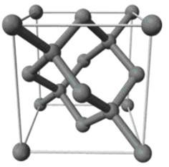

Figure 1: Unit cell of silicon single crystal showing diamond FCC structure
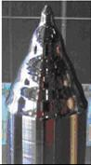
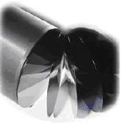

Figure 2: Ingot of Si single crystal from which the silicon wafer is cut
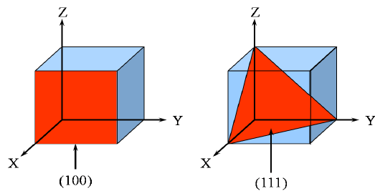
Two common orientations are shown in Figure 3, below, where the Miller indices of the wafers are [100] and [111]. From the figures, one can see that the unit cells in the two configurations will produce crystals which cleave naturally either into cubic structures (or rectangular-like under microscope) or triangular structures with 45 degree angles from tetrahedral like crystals. A stable 1.5 nm thick oxide forms within six minutes after cleaving of an atomic Si crystal surface.

Figure 3: [100] and [111] Miller indices corresponding to possible slicing directions of the Si single crystal of cubic and tetrahedral, respectively [http://www.periodni.com/en/si.html]

In order to prepare the Si surface for spin coating, it must first be cleaved into small square pieces of 1 x 1 cm² and then cleaned off dusts and small particles absorbed from atmosphere using nitrogen gas.
After silicon is cleaved, the crystal structures can be seen on the back of silicon wafer (where there is not polished or smear off the crystal boundary) using optical microscope. And, its surface property can be observed by water contact angle. The nature of silicon is more hydrophobic but silicon can automatically reform with oxygen and moisture into oxide layers deposited on the surface that modified the surface into hydrophilic.
Before spin casting, the silicon substrate needs to be cleaned to remove all organics and oxide layers off of the surface by submerging in a mixture of organic solvents of 4:1:1 of H₂O : H₂O₂ : NH₄OH at 80 °C for 15 min. Please follow the directions in the experimental section. The surface property should be investigated by water contact angle.
To modify the surface to be hydrophobic so to be ready for coating with polystyrene thin- film, the Si substrate will be treated with HF for 30 seconds at room temperature (seen in an experimental section). And, its surface property should be investigated by water contact angle.
Experimental section:
Materials, Equipment and Methods:
Silicon wafer (Si) with miller index [100], Diamond cutter, Tweezers, Safety goggles, Nitrile gloves, Nitrogen gas (under pressure ~ 4 mPSI), measured Pipettes, measured bubble ball, hot plate, aluminum foil, pirate Beakers
Experiment I: Si Cleaving and its crystal observation
- Be careful of sharp flying chips.
- Wear Goggles at all times in the laboratory.
- Do not touch anything, pieces even the waste with bare hands. They are very sharp. Always dispose silicon in sharps safety bin.
- Cleave silicon wafer: Start with wafer face up (shiny side up) on a clean room cloth (Do not use Kimwipes!!!). You should be wearing Nitrile gloves and handle the wafer using clean tweezers. Do not ever touch the Si wafer directly with your hands because you will contaminate the surface with proteins and dust from your hands. Cleave the Si wafer with the diamond cutter into pieces which are approximately 1 x 1 cm².
- IMPORTANT: The size of the cleaved Si pieces should be larger than the chuck on the spin coater to prevent polymer from entering the vacuum line!!!
- Dust off with N₂ gas: Take the wafer right after cleaving and brush any small remaining dust and silicon particles with a stream of nitrogen gas under ~ 4 mPSI.
- Collect Si in cleaned Petri dish: Place cleaved Si wafer pieces in Petri dishes. These Si will be used as substrates for your polymer thin-films.
- Remember that when Si wafers are cleaved, small pieces left behind are extremely sharp and very dangerous to eyes!!! Si waste must go to the sharp edge waste disposal bin.
- Examine silicon crystal using x-ray optical microscope: To examine Si crystal structures in which the Si is cleaved, students will learn how to use x-ray optical microscope to observe crystal structures. Suggestions: Students should make good observations on: Are the crystal structure like square or triangular? What does this mean regarding the orientation of the wafer?
1.1 Optical Microscope
Place one of the cleaved Si samples on the stage of the optical microscope. Examine both the polished and the reversed rough sides of the silicon. Store a good digital image of the rough side. Examine Si wafers which cleaved in other configurations (with magnification of 10x and 50x) under the optical microscope and store a clear image of the rough side.
1.2 Image Analysis:
Using ImageJ or Photoshop or any other image analysis program, determine the angles and the features of the reversed side of the Si crystals. Measure at least ten angles and find the average and standard deviation of the angles. Discuss the orientation of the Si wafer which you are using based on the results.

Experiment II: Silicon Cleaning and surface Modification
- Extreme care and precautions must be attentive at all times in handling these chemicals and disposing them.
- Wear nitrile gloves and goggles at all times. Follow instructions of the TA at all times.
- Immerse silicon wafer into Methanol, then sonicate for 10 min
- Immerse silicon wafer into fresh mixed 4 : 1 : 1 H₂O : H₂O₂ : NH₄OH at 80° C for 15 min. to remove any organic contamination
- Rinse with deionized water 3 times. Save at least one wafer for contact angle measurements and label properly.
- Immerse silicon wafer in a mixture of 5 : 1 H₂O : HF at room temp. for 30 seconds to initially etch silicon oxide layers off
- Rinse with deionized water 3 times. Now the surface is initially HYDROPHOBIC. Save at least one wafer for contact angle measurements.
- Dry every single piece of Si with N₂ gas
- Then investigate the contact angle at least three acceptable angles for each piece
- Compare the average angles of Si without cleaning with cleaning Si and with surface modified Si. If the Si surfaces need to be deposited with hydrophilic polymers, the following steps need to be done before thin-film deposition
- Then submerge in fresh mixed 3 : 1 : 1 H₂O : H₂O₂ : H₂SO₄ at ~ 100° C for 30 min. to remove any ionic/metallic impurities and create new oxide layer
- Rinse with deionized water 3 times. Now the surface is HYDROPHILIC. Save at least one wafer for contact angle measurements.

1.3 Contact Angle
Extreme Cautions:
- Perform each measurement at least three acceptable values in order to obtain proper statistics on each Si surface.
- Never touch Si wafer with bare hands. Use gloves and tweezers at all times because in addition with the danger of contacting acids, the oils on your hands will contaminate the Si surface.
- ALWAYS USE DISTILLED DEIONIZED WATER!

- Measure 5 μL of distilled deionized water using micropipette to drop on the surface
- Place one at a time of a Si wafer to measure water contact angle of
  - Si before cleaning procedures
  - Si after cleaning to remove all organics and
  - Si after modified surface with HF
- Measure the contact angle of each surface to obtain angle on the left and right at least three acceptable angles
- Average the measured angle on the left (θ_{L}) separately from the right (θ_{R}) and calculate their standard deviation
- Explain: Why the angle on the left and right cannot be average together? What the angle means to you if it leans toward 90° or/and if it leans away from 90°? What surface should exhibit the most hydrophobic and why? What surface should exhibit the most hydrophilic and why?
2. Spin casting
Solution spin casting is the simplest method used to create thin films from solution using centrifugal force. By drop small amount of polymer solution (or chemical solution) onto spinning head (mold or flat surface), then spinning the solution (rpm) for few seconds or minutes, the centrifugal force (force used for circling the spinning head around the motor axis) will provide enough force to spread out the solution droplet into thin film layers coated on top of the silicon surface.
2.1 Solution preparation
Proper solution of polymer has to be prepared prior to spin-casting. The concentration of the polymer solution needs to calculate as weight of polymer per volume of organic solvent. For polystyrene, the solvent is toluene. The preparation needs caution and should perform under vacuum hood at all time. The concentrations needed are 5, 10, 20, 30, 50 and 70 mg/ml. Significant numbers from a scientific scale in the laboratory need to be accurate in order to obtain proper concentration in mg/ml.
2.2 Standard Curve
After spin-casting polymer thin film onto silicon wafer, the thickness in Angstrom (measured by ellipsometer) and the concentration in mg/ml of the PS solution should be plot in log-log scale as Figure 4.

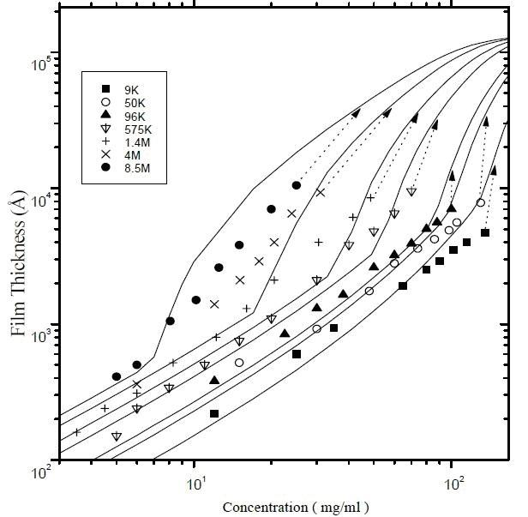

Figure 4: By an ellipsometer, thickness (°A) of PS thin-films obtained from spin-casting under
2500 rpm for 30 s plotted against PS concentration of known MW [5]

3. Ellipsometry
Ellipsometry is a technique that has been used since the 1960’s, primarily in the study of semi-conductors and electronic materials. It measures the change in polarization state of light reflected from the surface of a sample. The measured values are expressed as ψ and Δ. These values are related to the ratio of the Fresnel reflection coefficients, R_{p} and R_{s}. The subscription ‘P’ is for light reflected parallel and ‘S’ is light reflected perpendicular to the plane of incidence.

Ellipsometers are instruments that measure the ratio of as ψ and Δ. There are several advantages of using this technique to measure the thickness of a thin film including high accuracy, high reproducibility, and ability to take measurements without a reference sample and low susceptibility to scattering, lamp or purge fluctuations. An ellipsometer offers high sensitivity to ultra-thin films (<10 nm) and also provides two thickness measurements at each wavelength.
A linear polarized light beam of an ellipsometer is converted to an elliptically polarized reflected beam. For any angle of incidence between zero and ninety degrees, P-polarized light and S-polarized light will reflect differently. The measurement of these two values allows the relative phase change (Δ) and relative amplitude change (ψ) from the reflected surface to be determined. These values can be used to measure film thickness. Ellipsometry relies on the reflection of polarized light to determine the refractive index profile at an interface.
To measure the thickness of the thin films using an ellipsometer, an index of refraction of polystyrene is set at 1.5894 and silicon substrate at 3.875.

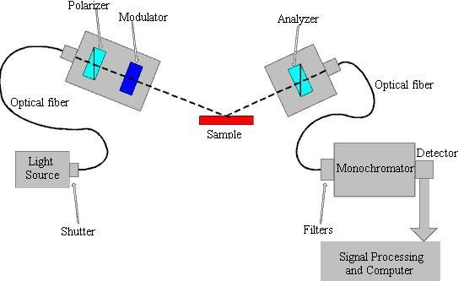

Figure 5: Diagram of an optical ellipsometer (http://www.jobinyvon/usadivisions/TFilms/coretech.html

References:
[1] Chen, C.; An, I.; Ferrira, G. M.; Podraza, N. J.; Zapien, J. A.; Collins, R. W. Thin Solid Films 455-456 (2004): 14-23
[2] Krisztia'n Kordas; Jouko Vahakangas, Antti Uusimaki, Seppo Leppavuori, Laurent Pilon, Sandor Szatmari. 'Optical properties of proous silicon Part III: Comparison of experimental and theoretical results' Optical Materials. 28 (2006): 506-513
[3] S. Lazarouk, P; Jaguiro, S; Katsouba, G; Maiello, S; La Monica, G; Masinic, E; Proverbio, A; Ferrari, V. 'Visual determination of thickness and porosity of porous silicon layers'. Thin Solid Films 297 (1997): 97-101
[4] http://ecee.colorado.edu/~bart/book/ellipstb.htm and http://refractiveindex.info/?
group=PLASTICS&material=PS

[5] Vladimir Shapovalov, Vladimir S Zaitsev, Yuri Strzhemechny, Faiqa Choudhery, Wei Zhao, Steven A Schwarz, Shouren Ge, Kwanwoo Shin, Jonathan Sokolov, Miriam H Rafailovich. ‘Nanostructure formation in spin-cast polystyrene films’ Polymer International 2000; 49(5): 432–436
[6] Lekner, John. "Ellipsometry of anisotropic media," J. Opt. Soc. Am. A 10 (1993) 1579-1581.
[7] Beaucage, G.; Composto, R.; Stein R. S. ―Ellipsometric study of the glass transition and thermal expansion coefficients of thin polymer films‖ J. Polym. Sci. B: Polym. Phys.31(1993) 319–326.

4. Molecular Weight Determination
To determine the molecular weight of unknown polymers, the comparison of the concentration at the thickness of 3000 °A can be extrapolated to find the corresponding MW from the following plot (Figure 6). The estimated MW can be calculated by choosing a proper equation below.
Table: Molecular weight equation of 3000 °A PS thin film
Molecular Weight | Equations
9,000 | log(y) = 1.00483 + 1.25719log(x)
875,000 | log(y) = 1.133 + 1.510log(x)
1,450,000 | log(y) = 1.337 + 1.525log(x)
4,000,000 | log(y) = 1.038 + 1.954log(x)
8,500,000 | log(y) = 1.095 + 2.105log(x)

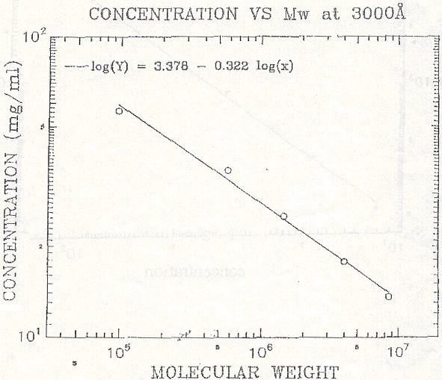

Figure 6: The given plot of concentration (mg/ml) vs MW of polystyrene with the thickness of 3000°A
From thickness data obtained from ellipsometer, students must be able to understand the concentration related film thickness and establish a graphical plot of standard curve of thickness (°A) vs concentration (mg/ml) in a log-log plot. Students should then be able to estimate the concentration needed for spin casting to create the 3000 °A thick of the PS film.
After spin casting the polymer film onto silicon wafer, students should be able to measure the thickness using Ellipsometer.
Then students should be able to locate the actual concentration of the unknown-MW PS from the data of the thickness vs concentration (a standard curve) of the known-MW PS. This actual concentration will then allow students to estimate the molecular weight of the unknown polymer from the plot of concentration and molecular weight (Figure 6). Then students should be able to use the proper equation to determine the molecular weight of the unknown-MW PS.

References:
[1] Schubert, D. W. ―Spin coating as a method for polymer molecular weight determination. Polymer Bulletin 38 (1997) 177-184.
[2] Ander, Paul. J. Chem. Educ., 47(1970) 233-234.

5. Compression Molding
Compression Molding is a process in which a polymer pellet is squeezed into a preheated mold taking a shape of the mold cavity before curing due to heat and pressure applied to the polymer. The common method uses are called a split mold which molds mounted in a hydraulic press.
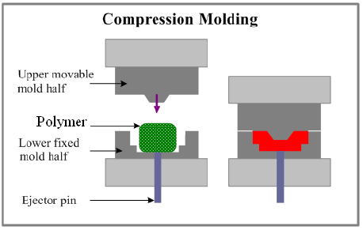
Figure 7: Compression molding process
Compression Molding process involves the following steps:
  - A pre-weighed amount of a polymer is placed into the lower half of the mold. The polymer may be in form of powders, pellets, flakes.
  - Usually polymer is preheated prior to apply pressure into the mold. Since preheating polymer helps polymer to become softer, the result leads to shorten the molding cycle time.
  - The upper half of the mold moves downwards, pressing on the polymer and then forcing polymer to fill the mold cavity.
  - The mold is equipped with a heating system. The high temperature provides curing (leading to cross-linking) of the polymer. The polymer cross-linking maintains polymer shape and dimension.
  - Once the mold cooled down, the mold is opened and the part is removed from it by the ejector pin.

6. Fourier Transform InfraRed (FTIR)
In FTIR spectroscopy, infrared radiation is passed through a sample. Some of the radiation is absorbed by the sample and some of it is passed through (transmitted). The resulting spectrum represents the molecular absorption and transmission, creating a molecular fingerprint of the sample. Like a fingerprint, no two unique molecular structures produce the same infrared spectrum. This makes FTIR spectroscopy useful for several types of analysis:
- It can identify unknown materials
- It can determine the quality or consistency of a sample
- It can determine the amount of components in a mixture
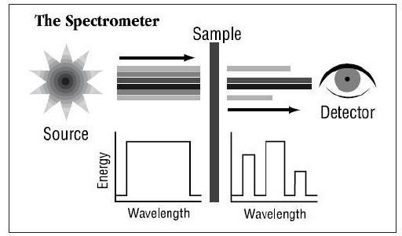
Figure 8: scheme of the FTIR instrument
Using polystyrene (PS) thin film, the FTIR measurement can identify the structure of
polymer. The PS 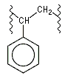can be polymerized by free radicals from styrene monomers.
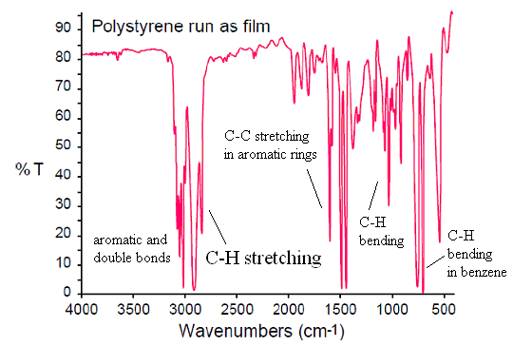

Figure 9: FTIR spectra of polystyrene
At wave length 3000 cm⁻¹, the spectra both higher (3000-3100 as aromatic and double bonds and 3300 cm⁻¹) and lower wavelength (2800-3000 cm⁻¹) represent the unsaturated and saturated C―H stretching. The spectra of the aromatic rings also show at 1500-1600 cm-1 (as C―C stretching). The spectra around 690-860 cm⁻¹ represent the C―H bending of benzene rings. The spectra at 1000-1200 cm⁻¹ represent C-H bending. (http://www.personal.psu.edu/sxp928/SP_IR.htm)
7. Contact Angle
Spreading of liquids on either solid or liquid surfaces is a common phenomenon. In microscopy, spreading is a molecular process to minimize its total surface energy.
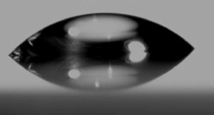
Figure 10: A water drop on glass surface
Consider a droplet on a surface as shown in the Figure 11 below. When the two surfaces meet, they form a contact angle, θ, which is the angle tangent to the liquid surface makes with the solid surface.

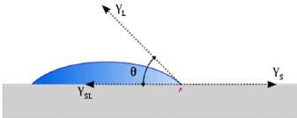

Figure 11: A droplet on a surface
At point P, there are three forces that act on the droplet. These forces are represented by the arrows in the Figure 11. If the droplet is not spreading, the forces are at equilibrium and their vector summation must be zero. This criterion is responsible for the observed contact angle.
If γ_{S} is the surface tension of the solid surface, γ_{L} is the surface tension of the liquid and γ_{S} is the interfacial energy between the liquid and the solid surface.
At equilibrium:
The contact angle is therefore a measure of the surface forces between a liquid and a surface. In other words, the contact angle of water with the surface can determine the surface properties as hydrophobicity and hydrophilicity while different solvents and liquid droplets can measure wettability of the surface to the liquid.
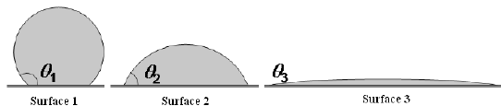
Figure 12: A drop of deionized water onto different surfaces
Considering a liquid dropped on a solid surface, if the liquid is very strongly attracted to the solid surface (for example water on a strongly hydrophilic solid), the droplet will completely spread out on the solid surface and the contact angle will be close to 0° (like water on the Surface 3 in Figure 12). Less strongly hydrophilic solids will have a contact angle up to 90°. On many highly hydrophilic surfaces, water droplets will exhibit contact angles of 0° to 30° (Surface 2 in Figure 12).
In the experiment, students will investigate the interaction of the surface with deionized water. Therefore, the degree of hydrophobicity can be proportional to the measured contact angle.

References:
[1] Shiraki, Hiromitsu. ―Silicon Wafer Annealing Effect in Loop Defect Generation‖ Jpn. J. Appl. Phys. 13 (1974) 1514-1523.
[2] Dee, G. T.; Sauer, B. B. The surface tension of polymer liquids, Advances in Physics, 1998,47, 161-205
[3] Sauer Bryan. Direct measurement of molten poly (ethylene terephthalate) contact angles on single aminopropylsilane coated glass fibers, J. Adhesion Sci, Technol., 1992, 6, 955-968
[4] ASTM D 1331 Standard test method for surface and interfacial tension of solutions of surface active agents
[5] ASTM D 1590 Standard test method for surface tension of water

