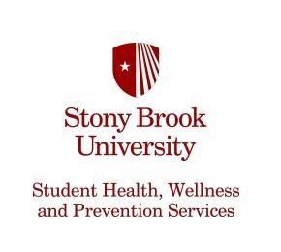
Student Accessibility Support Center (SASC)
128 Educational Communications Center (ECC)
(P) 631-632-6748
(F) 631-632-6747
sasc@stonybrook.edu
stonybrook.edu/sasc

RELEASE OF INFORMATION

I, , authorize Student Accessibility Office (SASC),
(student name)
and/or professionals assisting SASC, to provide information relating to
_____ to _ ,
(disability) (provider/guardian)
for the purposes of evaluating, determining and/or implementing accommodations at Stony Brook University.

I understand that this authorization is voluntary and I may refuse to sign it. This authorization will expire at the end of the academic year in which I sign it. I understand that I may revoke this authorization at any time by providing written notice to SASC.

Provider/ Guardian Phone Number:_____ ___ _________________________________________
Provider/Guardian E-mail:_________ ___________________________________________________

Signature Date

Print Name Student ID#

